Level 11 -> Level 12

The goal of this level is to read the content of **data.txt** file and get the password where all lowercase (a-z) and uppercase (A-Z) letters have been rotated by 13 positions.

In this problem, lowercase and uppercase alphabets are translated by rotating by 13 positions i.e. A is written as N, B is written as O … and so on.

**Here, tr** command is useful to rotate back the letter to their original form.

Command used is **cat data.txt | tr ‘N-ZA-Mn-za-m’ ‘A-Za-z’**

**Tr** stands for translate and **‘N-ZA-Mn-za-m’** means that our input starts with the letter N and continues through the letter Z, then continues with the letter A through the letter M. Similarly, for lowercase letters. And we want to translate our input such that it gives us output that starts with letter A and continues through the letter Z.

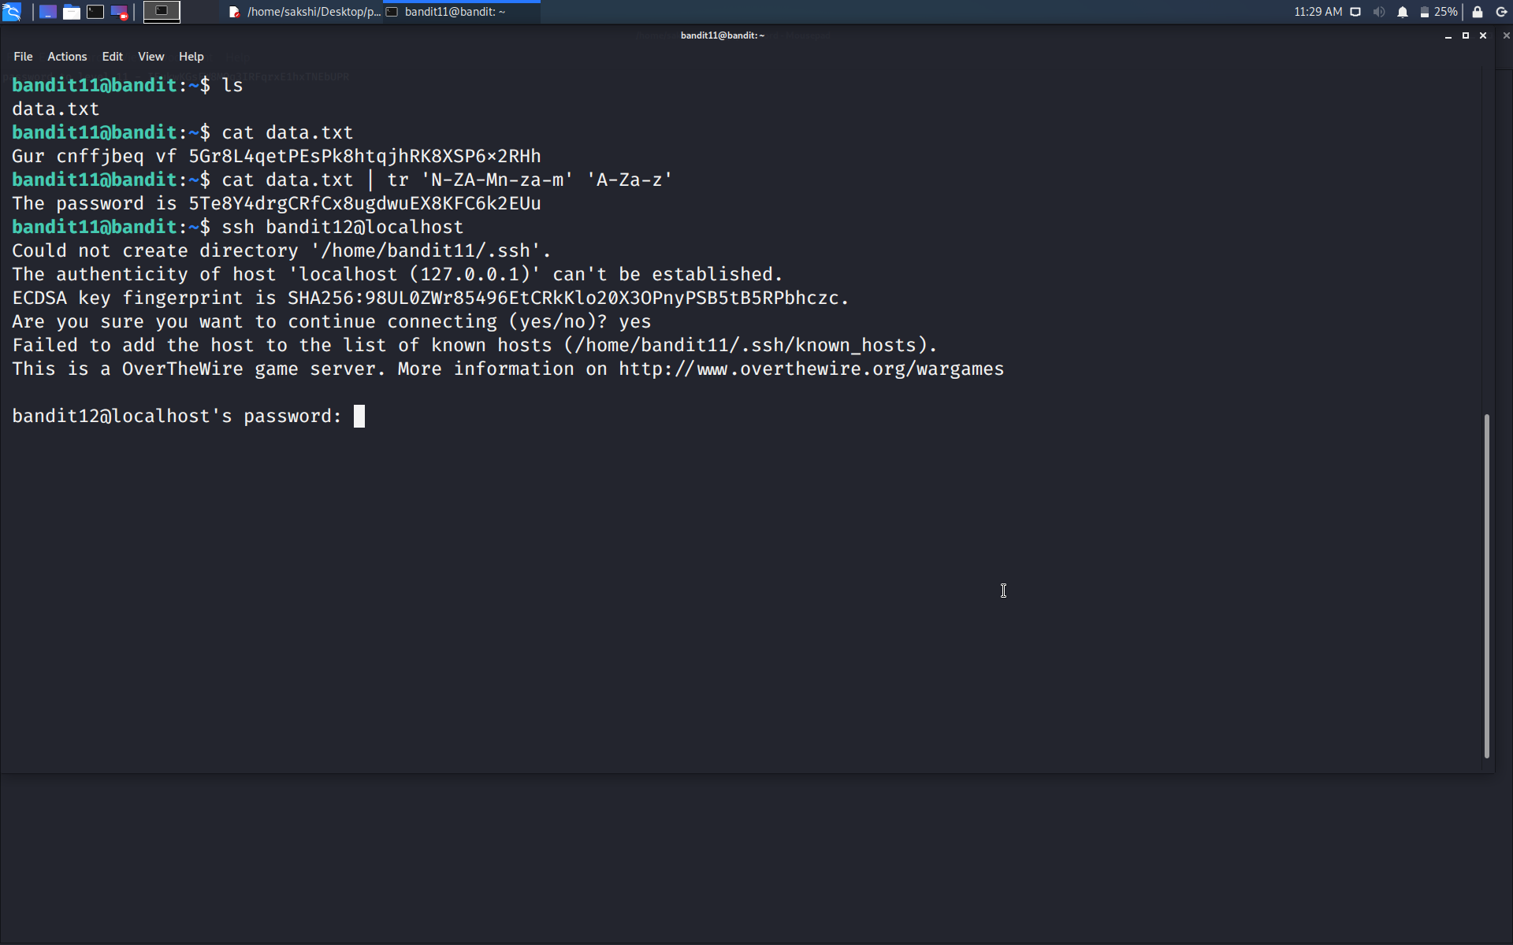

Use the command **ssh bandit12@localhost** to connect to the level 12.

Enter the password and hit enter.

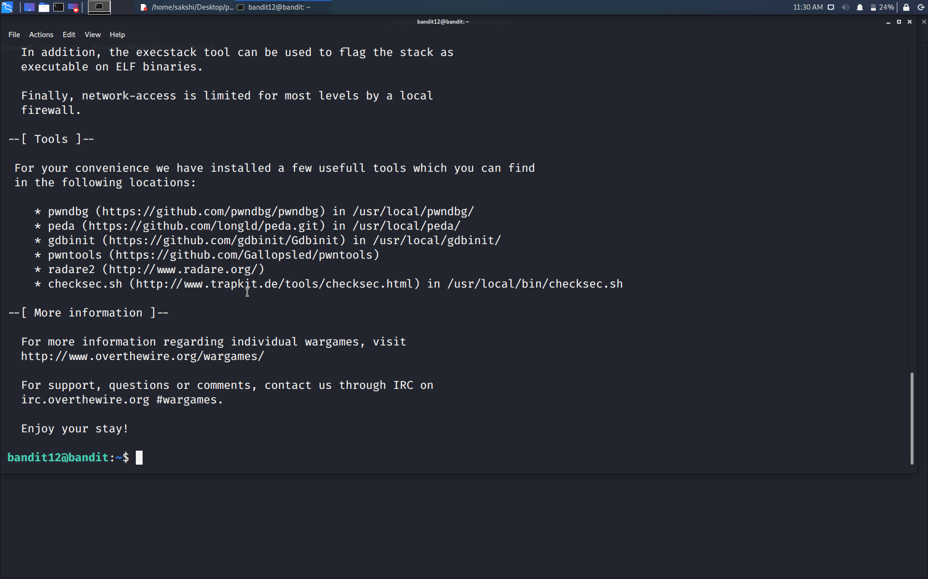

Successfully passed level 12.…